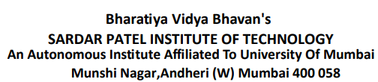

**C.I.T.L. EXPERIMENT 4**

**Topic : Inventory Management System**

**Submitted By:**

|  |  |
| --- | --- |
| Akash Panicker | 2021300089 |
| Mahesh Patil | 2021300095 |
| Rohit Phalke | 2021300100 |
| Adwait Purao | 2021300101 |

**Submitted To:**

Prof. Sunil Ghane

**Aim:**

Testing of restful web service using Postman/ARC.

**Problem Statement:**

Develop an inventory management system for a retail store that efficiently tracks and manages the inventory of products. The system should provide real-time updates on stock levels, generate alerts for low stock items, enable easy addition and removal of products, and offer insights into sales trends to optimize restocking decisions.

**Theory:**

* **What is Postman?**

Postman is a popular application for API development and testing. It provides a user-friendly interface for sending and receiving HTTP requests, and it includes a variety of features that make it easy to debug and manage APIs.

* **Uses of Postman**

Postman can be used for a variety of tasks, including:

* + Designing APIs: Postman can be used to design and document APIs.
  + Developing APIs: Postman can be used to develop and test APIs.
  + Testing APIs: Postman can be used to test APIs for functionality and performance.
  + Debugging APIs: Postman can be used to debug APIs by inspecting requests and responses.
  + Documenting APIs: Postman can be used to generate API documentation.
* **Benefits of Using Postman**

There are many benefits to using Postman, including:

* + Easy to use: Postman has a user-friendly interface that makes it easy to use, even for beginners.
  + Powerful features: Postman includes a variety of powerful features that make it easy to debug and manage APIs.
  + Free to use: Postman is a free application that can be used by anyone.
  + Cross-platform: Postman is available for Windows, macOS, and Linux.
* **Types of Requests and Their Brief Descriptions**

There are four main types of HTTP requests:

* + GET: The GET method is used to retrieve data from a resource.
  + POST: The POST method is used to submit data to a resource.
  + PUT: The PUT method is used to update data in a resource.
  + DELETE: The DELETE method is used to delete data from a resource.

Postman also supports a variety of other HTTP methods, such as OPTIONS, PATCH, and HEAD.

**Screenshots:**

1. **Making a GET request**

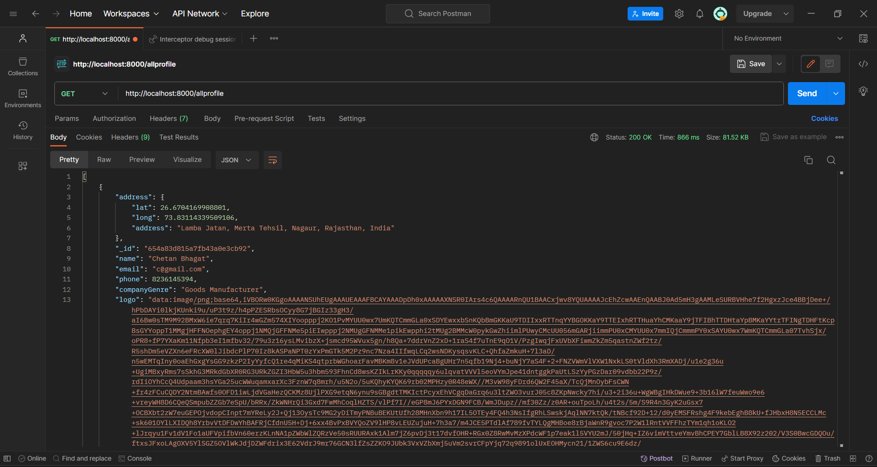

**GET request**

1. **Making a POST request**

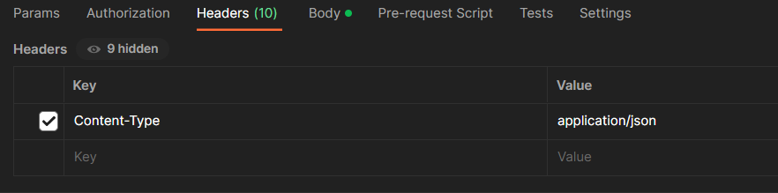

**Added header to identify the format of data**

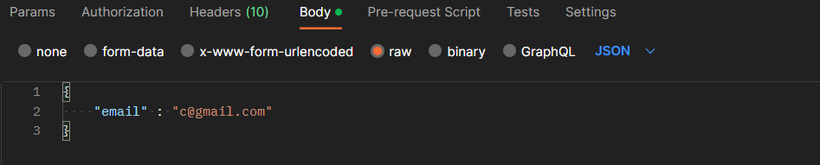

**Added email in the body of request to send with the request**

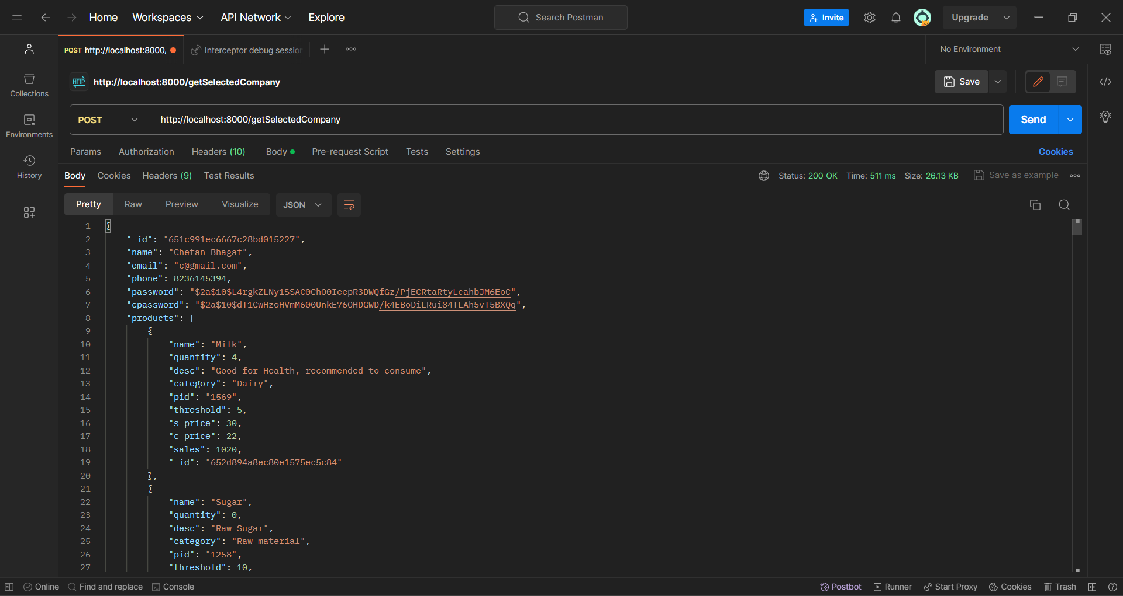

**POST request**

1. **Making a PUT request**

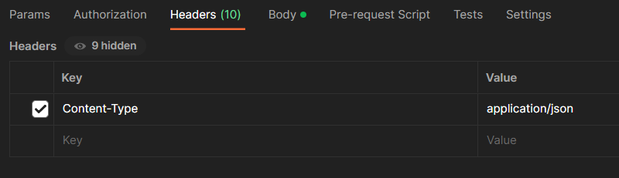

**Added header to identify the format of data**

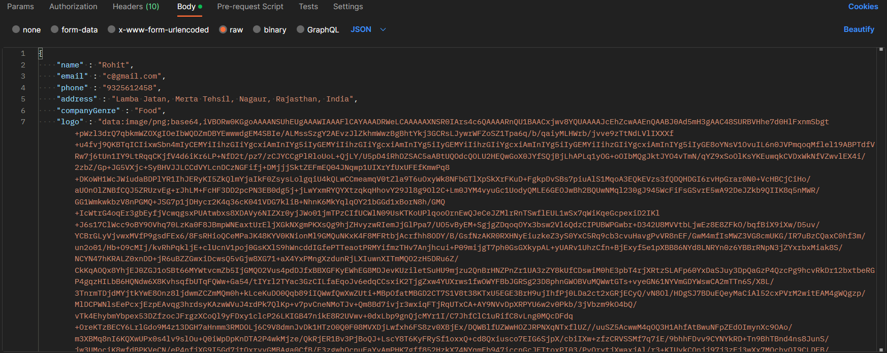

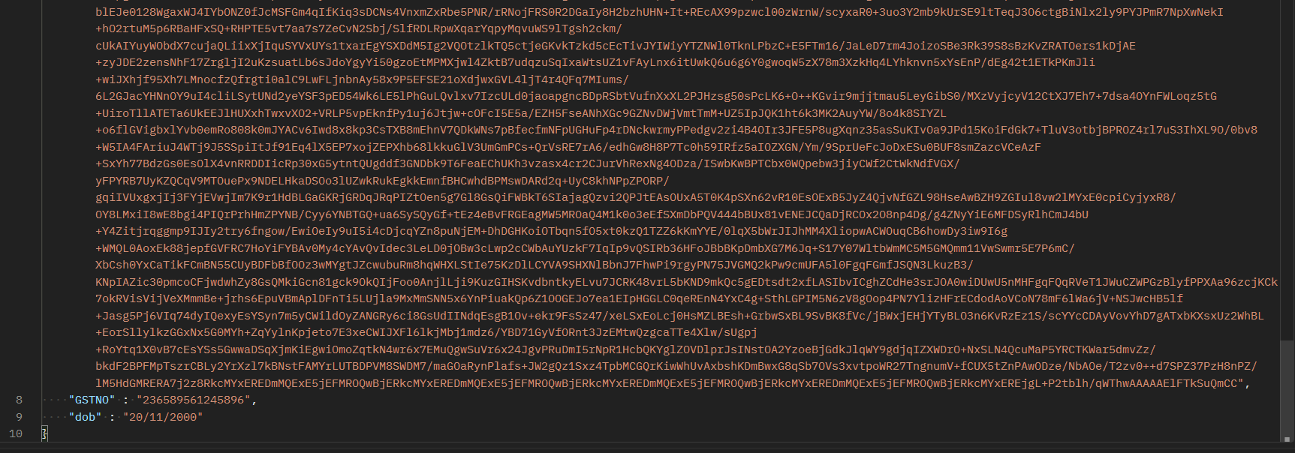

**Added data in the body of request to send with the request**

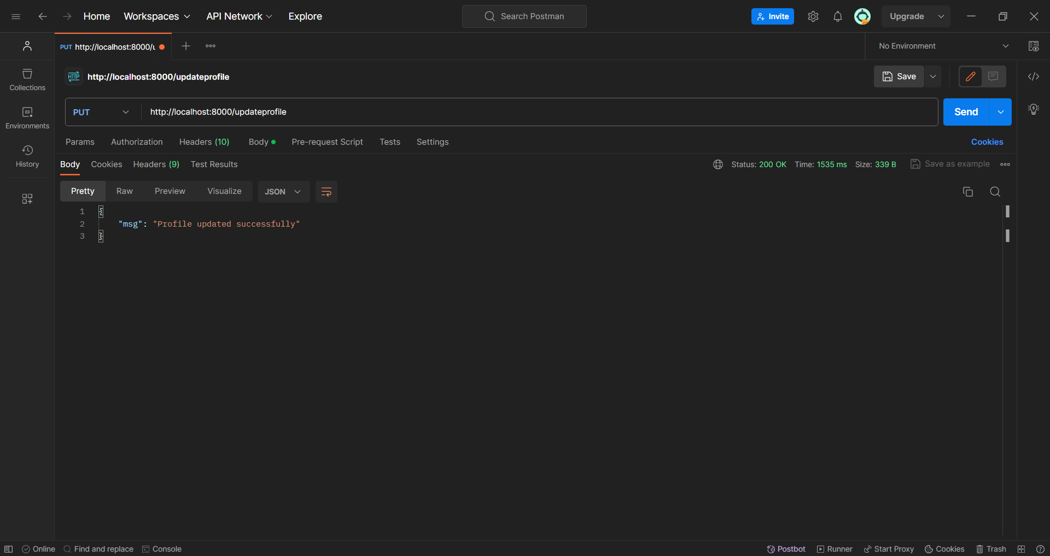

**PUT request**

**Conclusion:**

Postman has emerged as a powerful and versatile API development platform that has revolutionized the way APIs are designed, developed, and tested. Its user-friendly interface, comprehensive features, and wide range of integrations make it an indispensable tool for both API developers and consumers. Postman's ability to streamline the API development process, facilitate collaboration, and ensure API quality has made it a staple in the modern software development landscape.